(the numbers in the poem refer to line numbers)

Storm

by Hilda Doolittle

You crash over the trees,

you crack the live branch—

the branch is white,

the green crushed,

5 each leaf is rent like split wood.

You burden the trees

with black drops,

you swirl and crash—

you have broken off a weighted leaf

10 in the wind,

it is hurled out,

whirls up and sinks,

a green stone.

1. Lines 1–5 contribute to the development of ideas in the poem by

A. depicting the dramatic way a leaf falls in a storm.

B. mimicking the sound of a raging wind.

C. using colors to evoke the devastation of the storm.

D. describing the effect of a powerful storm on a tree.

2. What impact do the words “crash,” “crack,” and “crushed” in lines 1–4 have on the meaning of the poem?

E. Their similar sounds unite the first and second stanzas.

F. Their harsh sounds emphasize the fury of the storm.

G. Their rhythmic, repeated beginnings imitate the sound of the rain.

H. They provide a dramatic contrast to the quiet peace that follows the storm.

3. Read lines 1–2 and 6–8 that begin the two stanzas.

You crash over the trees,

you crack the live branch—

You burden the trees

with black drops,

you swirl and crash—

The purpose of the parallel structure of the two stanzas is to

A. contrast the effects at the start of the storm with those at the end of the storm.

B. indicate that the wind mentioned in the first stanza is less important than the rain.

C. emphasize that the second stanza will be a continuation of the first.

D. show that the first stanza was more important than the second.

4. Read lines 6–7.

You burden the trees

with black drops,

The lines help develop the theme of the poem by suggesting that the rain

E. is so heavy it may damage the trees.

F. will harm the trees because it is black from pollution.

G. is necessary for the growth of the trees.

H. will cause widespread flooding.

5.

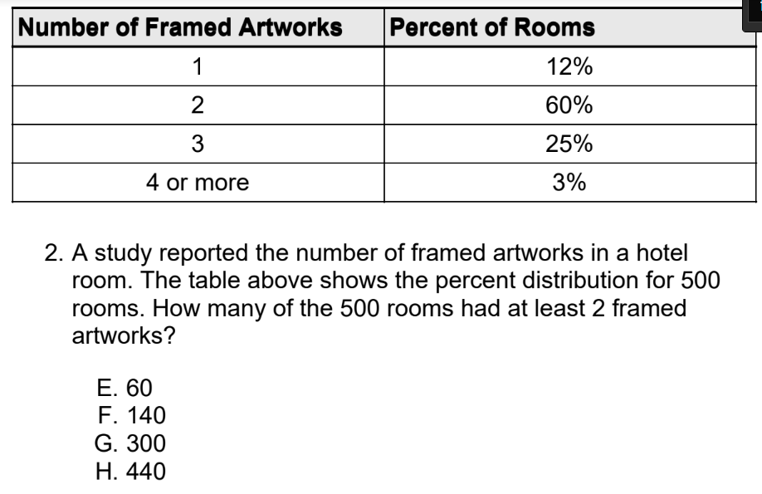

6.

